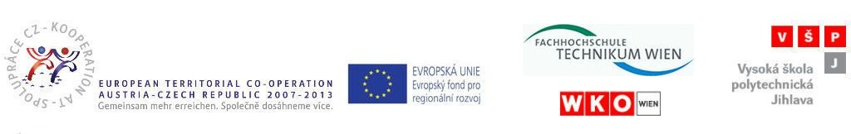

In Jihlava, 12th May 2010

Minutes of the workshop

Term of meeting: 12th May 2010
Location: BOSCH DIESEL s. r. o., Jihlava

The workshop and excursion took place in BOSCH DIESEL s.r.o. on 12th May 2010. The students from FHTW and implementaion team from VSPJ and FHTW participated in the workshop (attandance list attached).

The workshop was prepared for Austrian students. To show Austrian students the work process in the Czech partner company was the purpose of this event.
The FHTW students obtained:
- information about BOSCH DIESEL s. r. o., Jihlava
- the excursion around the company was arranged for them, in these departments:
- training center (they received information about the robot functions)
- production line CP3 (they received information about the whole production process on this line)

Excursion of the BOSCH DIESEL s. r. o. was ended with the excursion of Jihlava and information about its surroundings.
Then the students had free time and the implementation team from the both institutions had time to discuss the project issues during the snack in Radnicni Restaurant.

